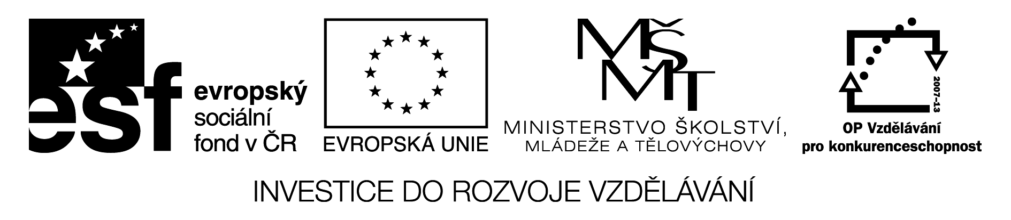

Quiz on Great Britain:

- Which two hemispheres are divided by the Prime Meridian?
- What is , in fact, Big Ben?
- What is the name of the square in London where the English set their meetings most often? ( It´s the same for Londeners as the statue of Saint Wenceslas on the horse in Wenceslas Square in Prague ).
- Who is the owner of Windsor Castle?
- What is the name of the famous English king who had 5 wives and a few of them survived?
- Who was the founder of Madame Tussauds?
- How many ravens are there in Tower Castle?
- How are the guards of the Tower Castle called?
- What is the the name of the most famous shopping street in London?
- What is the London Eye?
- What is the name of the youngest possible British heir to the throne?
- What´s the name of the most famous department store in London?
- What was the name of the Princ Charles´s first wife ?
- How many lions surround the Nelson´s column in Trafalgar square?
- What is the address of the British Prime Minister?
- Where does the English Queen live in London?
- What is the nickname of the British flag?
- What countries make the UK?
- What is the name of the most famous park in London?
- What is the name of Shakespeare´s theatre in London?

Instructions and solution:

1, East and west.
2. A huge bell.
3. Piccadily Circus
4. The queen.
5. Henry VIII.
6. Mdm. Tussauds
7. 8
8. Beefeeters
9. Oxford Street
10.A big wheel
11.George
12.Harrods
13.Diana
14.4
15.Downing Street 10
16.Buckingham palace
17.Union Jack
18.England, Scotland, Wales, Northen Ireland
19.Hyde Park
20.The Globe

